A framework for Quantitative Analysis
in Decision-Making – PART 1

- SWOT Analysis
STRENGTH: | WEAKNESS:
- In-patient hospital setting w/ multiple specialties.  - Organization – Kaiser Permanente Hospital. Nurse Staffing office for all units in the hospital. | - In-patient hospital with a constant nurse shortage.  - UNAC/UHW union based.  - Unhappy nurses due to high census and low RN availability.
OPPORTUNITIES: | THREATS:
- In-patient hospital has the ability to hire nurse travelers or registry RNs to cover those who wants to take a day off.  - Allowance of nurses to take needed vacations as needed, in a timely manner for staff satisfaction  - Better quality of care if RNs are happy. | - Union has constant involvement with nurse staffing due to staffing grievances.  - If requests are denied, nurses call out sick.  - Must overstaff to avoid nurse shortage in case of census surge.  - Possible fines, such a double time and a ½ for grievances submitted.

Cybernetic Drawing
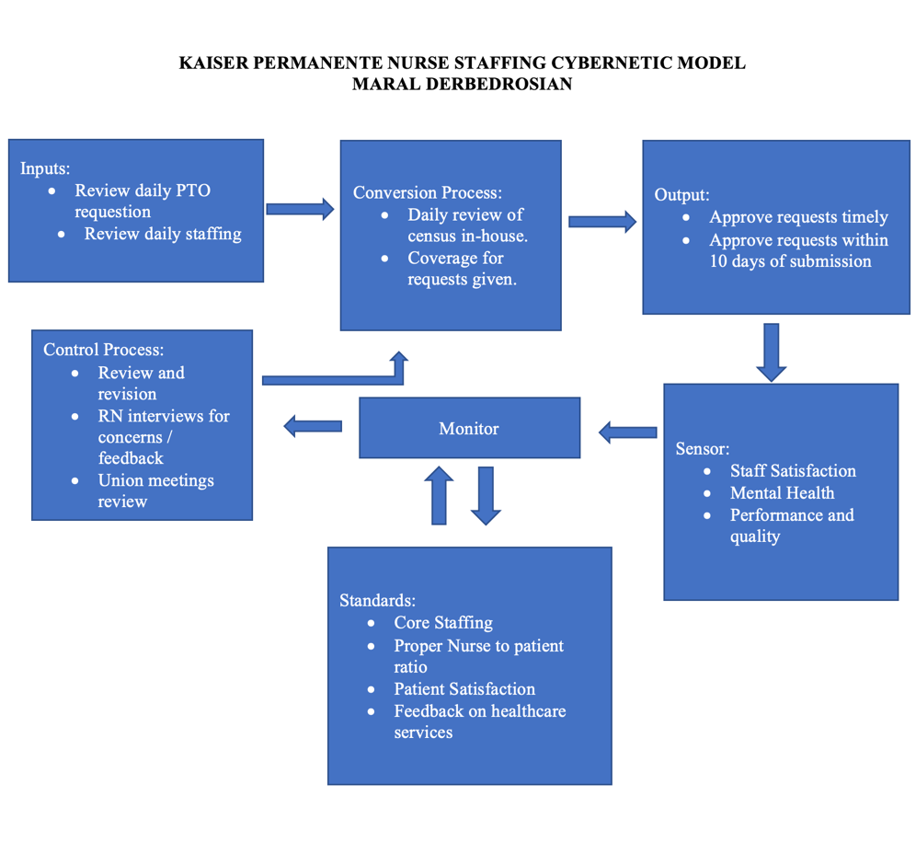

- Problem: A nurse has to follow a few steps before being able to be approved for PTO. We have to ensure the unit is staffed to core RNs minus one. The graph on the bottom explains when a RN will be approved or denied for a request. Their requests must be submitted fourteen days in advance to allow the nurse staffing office to find a RN to cover for the requestor. Also, the replacement must not have overtime. Many times, requests are denied due to staffing needs. When this happens, the RNs grieve to their union, and that’s where we run into issues. The problem is related to quality, costs, and provider/patient satisfaction. My aim would be to improve staffing for the hospital as a whole by 20% by next January. For example, we can out-source travel nurses and/or registry RNs to help give our regular nurses a break, especially after the pandemic.

Process: Nurse Staffing Time off Requests
Nurses: | Ratio: | Core Staffing:
ICU | (1:2) | 8 RN / 1 Charge
Stepdown | (1:3) | 15 RN / 2 Charge
MedSurg/Tele | (1:3/1:4) | 12 RN / 2 Charge
MedSurg only | (1:4/1:5) | 5 RN / 1 Charge

